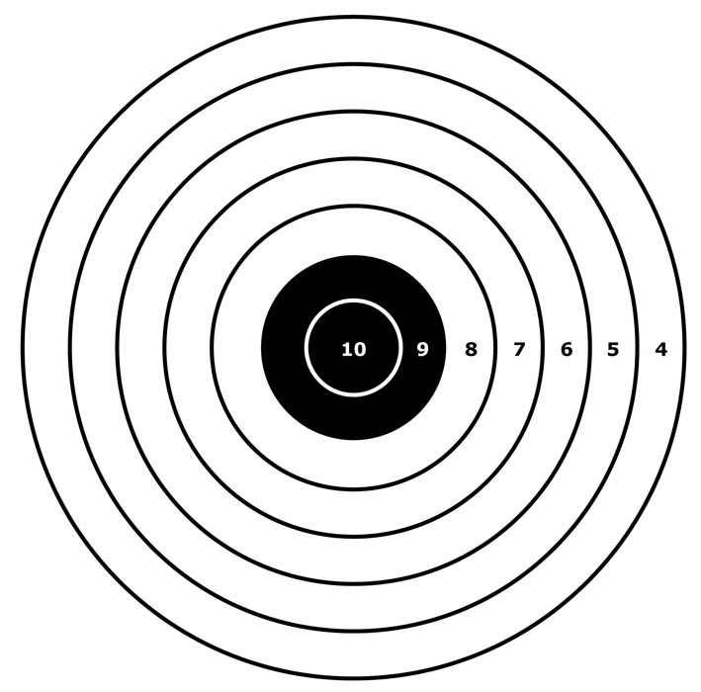
Camelot Air Rifle & Pistol
Postal Competition 2024
Camelot TSC are pleased to announce their open postal league for Precision and Sporter Air Rifles, plus Air Pistols, will run again in 2024.
The league is open to all ages but we do encourage newbie’s to the competition scene and especially juniors (U/21) from all clubs and organisations, e.g. Scouts, Cadets, Schools, Rifle Clubs etc so it presents a great opportunity to see how shooters measure up, especially as results are published via the Stats website – www.gbrshootingstats.uk - all welcome!
Guidance / Rules ~
Please get your entry forms to us by Wed. 31st Jan. 2024, (can accompany Jan. cards).
(Late Entries, with 2 months cards, to us by 29th Feb., note…. “Late fee” charged……)
Rifle shooters may enter any combination of the following rifle classes ~
- Six Yard Sporter Air Rifle ~ Pre-Charged (.177)
- Six Yard Sporter Air Rifle ~ Springer (.177)
- Ten Metre Precision Air Rifle ~ Pre-Charged (.177)
- Ten Metre Sporter Air Rifle ~ Pre-Charged (.177)
- Ten Metre Sporter Air Rifle ~ Springer (.177)
and then within the class each shooter may enter for 1, 2 or 3 positions,
i.e. Kneeling, Prone and / or Standing, in any combination, all shot within appropriate rules!
Pistol Shooters may also enter any combination of the following classes ~
- Six Yard Air Pistol (.177)
- Ten Metre Air Pistol (.177)
Shooters will shoot 20 competition shots, per entry, by the last calendar day of each month.
Only original NSRA targets may be used, no copies and no other types. (If in doubt ASK!!!)
For all Air Rifle targets, 2/89 or 3/89 at 10m, 7/89 at 6 yds, shooters will put 2 shots on each bull, i.e. 10 per target – unusual but of particular use to those who are “manual changers”!
For all Air Pistol targets, 4/89 at 10m, 8/89 at 6yds, shooters will put 5 shots on each target.
All shots for a position must be shot on the same day but different positions may be shot on a different day.
PRIOR to shooting targets must have CLEARLY written on the front of them, the competitors name and club, the word “Precis.” or “SAR”(PC) or “SAR”(Spring) or Pistol to denote the class, plus, position being used, and 1 or 2, etc for the order in which the cards are to be shot. This may be done by anyone and pre homemade stickers may be used, but….
they MUST BE LABELLED PRIOR TO SHOOTING AS ABOVE !!!
On the rear THE RANGE OFFICER, PRIOR TO SHOOTING, MUST SIGN the card behind the centre of the centre bull AND PRINT their name.
(REMINDER - ALL of the above MUST BE before the target is used)
ONCE SHOT the RO must sign the witness box, and add the date, on the front of the card to signify that they take responsibility for the card being a correctly shot valid entry.
Note - DO NOT score cards or gauge pellet holes.
When packaging cards please be mindful of how unforgiving some of the automatic sorting machines can be, a ring of sellotape all the way round an envelope in the middle of both the horizontal and vertical can be a “card saver”. If no cards are received and you have proof of posting we will issue a reshoot instruction, but damaged envelopes / cards that were not securely packaged cannot receive the same treatment.
Cards must be mailed to;
R.Monksummers
29 Cloverfields
Gillingham
Dorset
SP8 4UP
with a postmark no later than the 2nd weekday after the month end.
Those shooting SAR are required to shoot compliant to SAR competition rules, so pre competition is a good time to ensure rifles are indeed compliant, e.g. 500gms trigger weight – if in doubt on how to adjust read the manufacturers handbook! Also remember no barrel extensions or sights with any magnification (i.e. no telescopic sights), again if unsure ASK!
It is the RO’s job to ensure compliance and their signature on used targets is their personal confirmation of this.
For those who need Sporter Air Rifle (SAR) rules please go to www.sporter.org.uk and / or give Roger Monksummers a call – 07799810067
The cards from January and February will be entered into the national stats database, compared with any current / previous scores, and then a shooters ranking list for each position / class produced. Then, dependent on entry numbers, each of those lists will be split into divisions, and the cards for March to June inclusive will make up the competitive league from which medals will be awarded for 1st, 2nd, 3rd, plus…. All other shooters who complete and return on time all their league cards will receive a competitors medal to acknowledge their achievement.
All scores will be published via the internet at www.sporter.org.uk and added to the National Stats database www.gbrshooting.org.uk. Any and all junior clubs are welcome to contact Roger Monksummers for both a log in and teach in on how both staff and shooters can use the website.
The cost is £5.00 per entry but… for “Late Entries” – 1st Feb onwards - add £2.00.
There will be 3P aggregate medals for those who enter all 3 positions at no extra cost.
All communications / information will be communicated via “Latest News” at www.sporter.org.uk
For more information contact Roger Monksummers, tel. 07799 810067 or email roger.monksummers@sky.com

