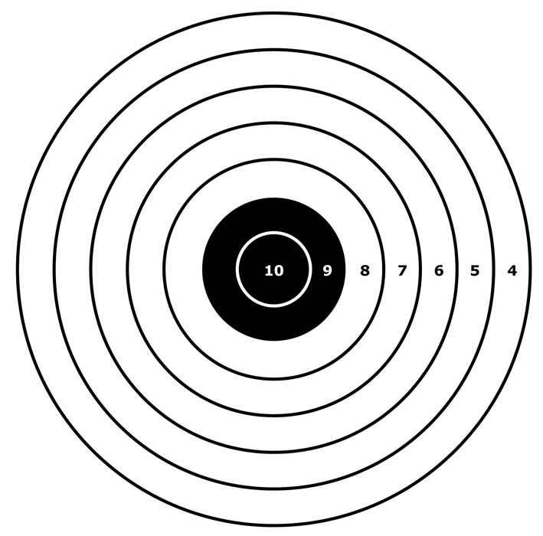Camelot Air Rifle & Pistol

AUTUMN Postal 2024

“Santa Special”

Camelot TSC are pleased to announce their open postal league for Precision and SAR (Sporter Air Rifle), plus Air Pistols, will run again in Autumn 2024. Last year was the second time we had run a Autumn comp in addition to our main competition held in the Spring.  
Following feedback, recognising that the Autumn term is a relatively short time window that has to “get into the flow” after the summer break and the commencement of new education years we have altered the format…. (read on)

The competition is open to all ages but we do encourage newbie’s to the competition scene and especially juniors (U/21) from all clubs and organisations, e.g. Scouts, Cadets, Schools, Rifle Clubs etc so it presents a great opportunity to see how shooters measure up, especially as results are published via the Stats website – www.gbrshootingstats.uk - all welcome!

**This year your main competitor will be yourself……. to encourage working on performance improvement through practice and coaching.**

**Every entry, that submits their 40 shots within time limits, will receive identical medals**

***Guidance / Rules ~***

**Please get your entry forms to us by** **Fri. 25 Oct. 2024.**

The Autumn series will be 2 Rds

with **“shoot by” dates of Thurs. 31st Oct. 2024 and Thurs 28th Nov.**

**cards to be sent 1st Class by the following day at the latest.**

Rifle shooters may enter any combination of the following rifle classes ~

* Six Yard Sporter Air Rifle ~ Pre-Charged (.177)
* Six Yard Sporter Air Rifle ~ Springer (.177)
* Ten Metre Sporter Air Rifle ~ Pre-Charged (.177)
* Ten Metre Sporter Air Rifle ~ Springer (.177)
* Ten Metre Precision Air Rifle ~ Pre-Charged (.177)
* Ten Metre Sporter Air Rifle ~ Pre-Charged (.177)

and then within the class each shooter may enter for 1, 2 or 3 positions,

i.e. Standing, Prone and / or Kneeling, in any combination, and all within discipline rules!

Pistol Shooters may also enter any combination of the following classes ~

* Six Yard Air Pistol (.177)
* Ten Metre Air Pistol (.177)

Shooters will shoot 20 competition shots, per entry, as per dates above.

**Only original NSRA targets may be used, no copies and no other types.**

**(If in doubt ASK!!!)**

For all Air Rifle targets, 2/89 or 3/89 at 10m, 7/89 at 6 yds, shooters will put 2 shots on each bull, i.e. 10 per target – unusual but of particular use to those who are “manual changers”!

For all Air Pistol targets, 4/89 at 10m, 8/89 at 6yds, shooters will put 5 shots on each target. PRIOR to shooting targets must have CLEARLY written on the front of them, the competitors name and club, the word “Precis.” / “SAR”(PC) / “SAR”(Spring) / Pistol to denote the class, plus, position being used, date and 1 or 2, etc for the order in which the cards are to be shot. This may be done by anyone and pre homemade stickers may be used, but….

they ***MUST BE LABELLED PRIOR TO SHOOTING AS ABOVE* !!!**

**On the rear THE RANGE OFFICER, PRIOR TO SHOOTING, MUST SIGN the card behind the centre of the centre bull AND PRINT their name.**

**(REMINDER - ALL of the above MUST BE before the target is used)**

**ONCE SHOT** the RO must sign the witness box, and add the date, on the front of the card to signify that they take responsibility for the card being a correctly shot valid entry.

**Note - DO NOT score cards or gauge pellet holes, unless you have an NSRA Qualified Scorer who has attached a copy of their certificate to the entry form, or with sent it with cards.  
NO OTHER PERSONS MAY SCORE – The NSRA Scorer Qual is the only acceptable one**

When packaging cards please be mindful of how unforgiving some of the automatic sorting machines can be, a ring of sellotape all the way round an envelope in the middle of both the horizontal and vertical can be a “card saver”. If no cards are received and you have proof of posting we will issue a reshoot instruction, but damaged envelopes / cards that were not securely packaged cannot receive the same treatment.

Cards must be mailed to;

R.Monksummers, 29 Cloverfields, Gillingham, Dorset, SP8 4UP

***with a postmark no later than the day after the “shoot by” date.***

Those shooting SAR are required to shoot compliant to SAR competition rules, so pre competition is a good time to ensure rifles are indeed compliant, e.g. 500gms trigger weight – if in doubt on how to adjust read the manufacturers handbook! Also remember no barrel extensions or sights with any magnification (i.e. no telescopic sights), again if unsure ASK!

It is the RO’s job to ensure compliance and their signature on used targets is their personal confirmation of this.

For those who need Sporter Air Rifle (SAR) rules please go to [**www.sporter.org.uk**](http://www.sporter.org.uk) and / or give Roger Monksummers a call – 01747 822202 or 07799810067

Scores will be entered into the national stats database, compared with any current / previous scores, and then a shooters ranking list for each position / class produced.

All scores will be published via the internet at [**www.sporter.org.uk**](http://www.sporter.org.uk) and added to the National Stats database **www.gbrshooting.org.uk**. Any and all junior clubs are welcome to contact Roger Monksummers for both a log in and teach in on how both staff and shooters can use the website.

**The cost is £4.00 per entry.**

***All communications / information will be communicated via “Latest News” at*** [***www.sporter.org.uk***](http://www.sporter.org.uk)

For more information contact Roger Monksummers, tel. 01747 822202 or 07799 810067

or email roger.monksummers@sky.com